**Ideation Phase**

**Brainstorm & Idea Prioritization Template**

|  |  |
| --- | --- |
| Date | 15 June 2025 |
| Team ID | LTVIP2025TMID49412 |
| Project Name | Measuring the Pulse of Prosperity: An Index of Economic Freedom Analysis |
| Maximum Marks | 4 Marks |

**Brainstorm & Idea Prioritization Template:**

Brainstorming provides a free and open environment that encourages everyone within a team to participate in the creative thinking process that leads to problem solving. Prioritizing volume over value, out-of-the-box ideas are welcome and built upon, and all participants are encouraged to collaborate, helping each other develop a rich amount of creative solutions.

Use this template in your own brainstorming sessions so your team can unleash their imagination and start shaping concepts even if you're not sitting in the same room.

Reference: <https://www.mural.co/templates/brainstorm-and-idea-prioritization>

**Step-1: Team Gathering, Collaboration and Select the Problem Statement**

**Problem Statement Selected:**  
How can we develop a comprehensive and accurate index that measures economic freedom across different regions or countries, in order to assess and compare their economic health and development?

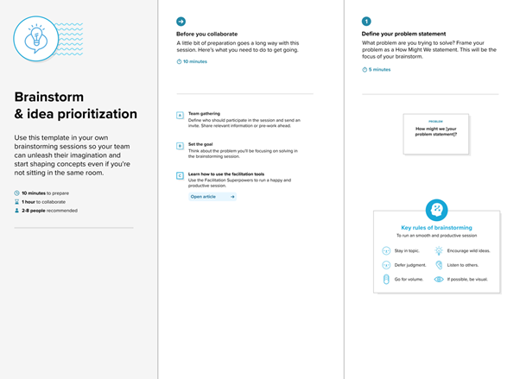

**Step-2: Brainstorm, Idea Listing and Grouping**

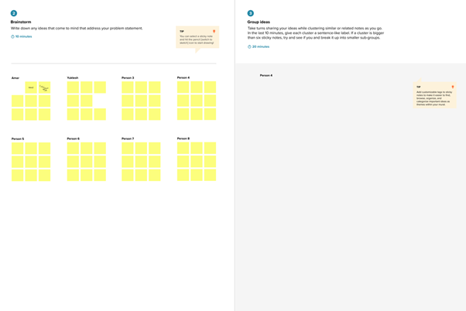

**Brainstormed Ideas:**

1. Use global indices like Heritage Foundation and Fraser Institute as baseline references.
2. Collect data on key economic indicators: trade freedom, fiscal health, government integrity, property rights, etc.
3. Apply data normalization and scoring techniques for uniformity.
4. Group countries into tiers based on economic freedom scores.
5. Use Tableau for interactive data visualization and storytelling.
6. Compare historical trends and predict future improvements.
7. Create a dashboard ranking countries/states by index score.
8. Include public policy suggestions based on findings.

**Grouped Under Categories:**

* **Data Collection: 1, 2**
* **Data Processing & Analysis: 3, 4, 6**
* **Visualization & Reporting: 5, 7**
* **Insights & Recommendations: 8**

**Step-3: Idea Prioritization**

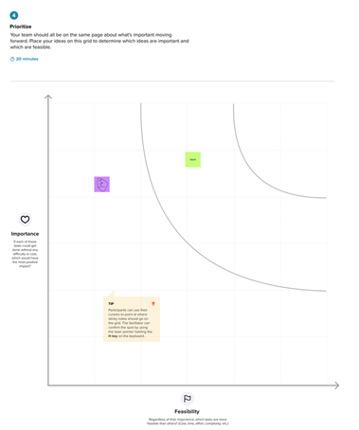

| **Idea** | **Priority (High/Medium/Low)** | **Reason** |
| --- | --- | --- |
| Use global indices as reference | High | Reliable benchmarks to start with |
| Collect key economic indicators | High | Core data requirement |
| Normalize and score data | High | Ensures comparability |
| Group countries by score | Medium | Helps categorize insights |
| Use Tableau for visualization | High | Clear presentation and storytelling |
| Predict future trends | Medium | Adds insight but requires models |
| Create dashboard | High | Easy interpretation of results |
| Policy suggestions | Medium | Valuable but beyond scope if limited on time |